The STS form is used by general practices to update their organisation and health practitioners details for the delivery of discharge summaries and clinical information received from Queensland Health.
Digital Health
Secure Transfer Form (STS) – Cheat Sheet
The STS form can be download and filled in online here

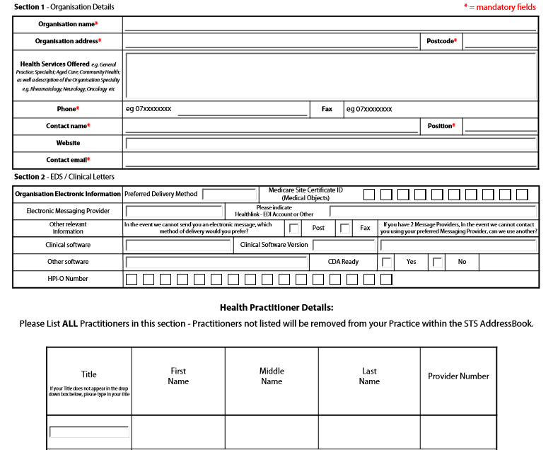

This cheat sheet will provide you with support on where to locate some of the information required on the form.

Section 2 EDS/Clinical Letters

Medicare Site Certificate ID (Medical Objects)
This is the General Practice’s site certificate registration number. The 10 digit code can be found:
- On the registration letter and/or CD received from Medicare.
- Online look webpage http://www.certificates-australia.com.au/general/cert_search_health.shtml
- Contact Medicare eBusiness Service Centre on 1800 700 199

CDA (Clinical Document Architecture) Ready
This is a standardised electronic exchange format in which a discharge summary can be sent and received within clinical software. More complex information structures such as Pathology results can also be exchanged using this format.
Clinical software which is CDA ready includes:
- Best Practice LAVA edition or higher
- Genie v8.8.6 or higher
- Medical Director v3.16b or higher
- ZedMed all version

To receive a CDA discharge summary document at your practice, first check that your clinical software version meets the above requirement, then contact eHealth Queensland via email EDSTV-Corro@health.qld.gov.au to request your practice be setup.

If your clinical software is not list above, please contact your software vendor to discuss their plans in supporting CDA format documents.

HPI-O Number (Healthcare Provider Identifier – Organisation)
General practices HPI-O number can be located on the confirmation letter received from Medicare or from within your clinical software.

Please see below for instructions to view your HPI-O within your clinical software:

Best Practice:
From the Setup Menu choose Practice Details. Click on the Change button
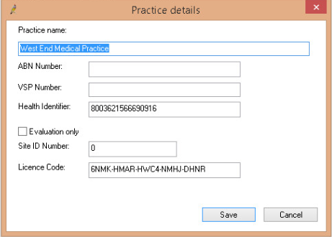
Medical Director:
From the Tools menu choose Options. Click on the Practice tab

Zedmed
From the Practice Setup menu choose Practice

Genie
From the File menu choose Practice Preference. Double click on the Clinic Name

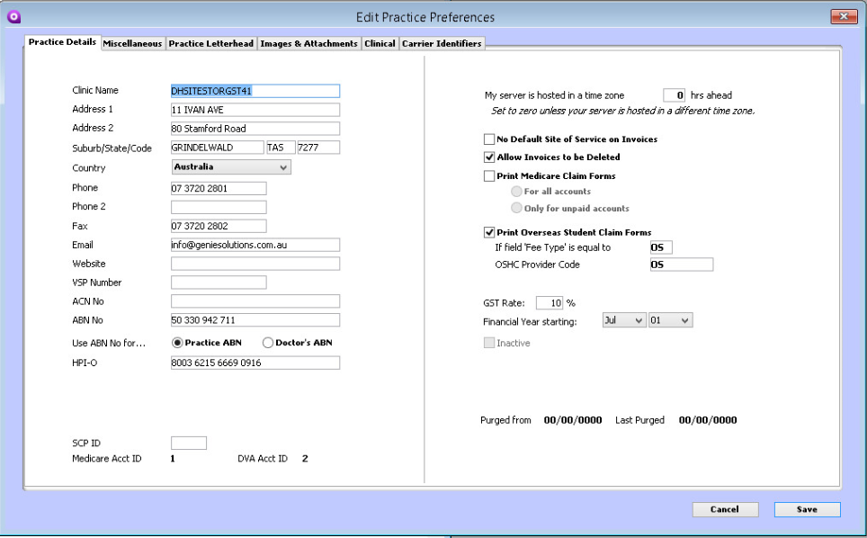

Health Practitioners Details

The health practitioners HPI-I (Healthcare Provider Identifier – Individual) and provider number can be find within your clinical software.
If the health practitioners HPI-I has not already been entered into your clinical software, it can be obtain by contacting AHPRA on 1300 419 495 (the GP would need to do this), for additional information click here
http://www.bsphn.org.au/wp-content/uploads/2014/06/HPI-I-numbers.pdf

To view health practitioners details within your clinical software

Best Practice
Click on the Setup menu and choose User. Double click on Health Practitioners name to display their details:
Health Identifier field is the HPI-I

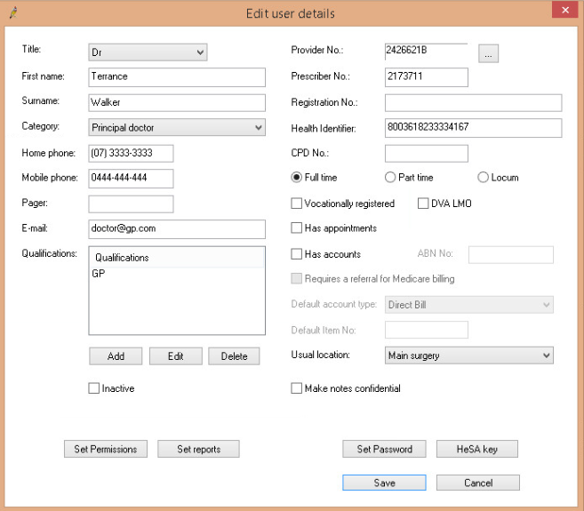

Medical Director
Click on the Users menu and choose Setup Users. . Double click on Health Practitioners name to display their details:

Zedmed
Click on the Practice Setup menu and select Doctors. Select Finding Treating Doctor from the sub menu. Search for the health practitioner via the family name or Dr Code fields.

Genie
From the File menu select All User Preferences. Double click on the health practitioners name to display their details:

Useful resources and information is available on the Brisbane South PHN Digital Health webpage
http://www.bsphn.org.au/primary-health-support/digital-health/

For enquiries or support please contact the Digital Health Team
Phone: 1300 467 265 or Email: ehealth@bsphn.org.au

